Name: Looi Kah Fung

Matric no: P-COM0049/22

Date: 7th Nov 2022

Course: Lab 3 CDS502 Principles & Practices of Data Science and Analytics





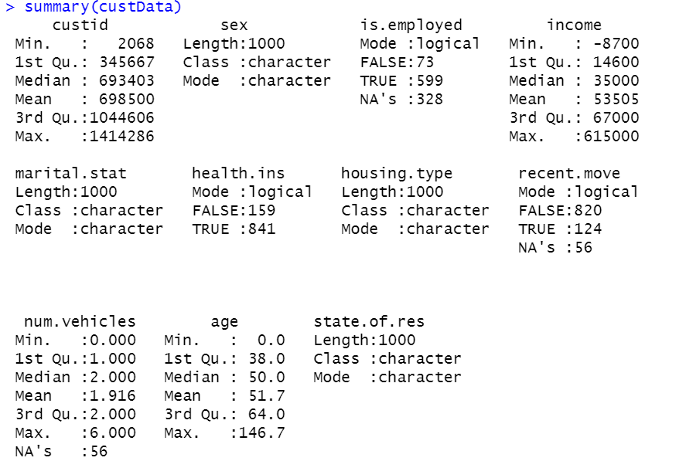

Recent.move & num.vehicles have 56 missing values.

AGE & TAX have +ve correlation.

